-------------------------------------------------------------------------

-- CREATE A DATABASE AND TABLES

-------------------------------------------------------------------------

CREATE DATABASE Project;

USE Project;

CREATE TABLE Realtors (

realtor_id int NOT NULL IDENTITY(1,1) PRIMARY KEY,

full_name varchar(255) NOT NULL,

comission float,

);

CREATE TABLE Apartments (

apartment_id INT NOT NULL IDENTITY(1,1) PRIMARY KEY,

street_addres VARCHAR(255) NOT NULL,

apartment INT NOT NULL,

number_of_bd INT NOT NULL,

square_footage FLOAT NOT NULL,

home_value money NOT NULL,

);

CREATE TABLE Sales_transactions (

sales_transaction_id INT NOT NULL IDENTITY(1,1) PRIMARY KEY,

sale_date DATE NOT NULL,

realtor_id INT NOT NULL FOREIGN KEY REFERENCES realtors(realtor_id ),

apartment_id INT NOT NULL FOREIGN KEY REFERENCES apartments(apartment_id),

);

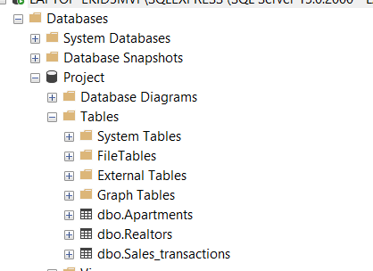

-------------------------------------------------------------------------

-- INSERTING DATA

-------------------------------------------------------------------------

INSERT INTO realtors (full_name, comission)

VALUES

('Que Foor', 0.02),

('Julie Flouty', 0.12),

('James Sherman', 0.04),

('Raziel Ungar', 0.13),

('Abe Matar', 0.06),

('Philip Watson', 0.023),

('Rumana Jabeen', 0.024),

('David Tapper', 0.038),

('David Martin', 0.03),

('Debbie Wilhelm', 0.06),

('Maximus Reinhardt', 0.05),

('Holly Noto', 0.07);

INSERT INTO Apartments(street_address, apartment, number_of_bd, square_footage, home_value)

VALUES

('100 Pierce St', 2, 3, 1250, 498000),

('20 Parkridge Dr', 7, 1, 715, 699000),

('988 Fulton St', 223, 1, 750, 799000),

('100 Pierce St', 3, 4, 1560, 454000),

('100 Pierce St', 4, 2, 980, 356000),

('1332 Palos Verdes Dr', 2, 2, 1500, 940000),

('54 Hilton Head Dr', 80, 3, 1620, 780000),

('5545 Canoga Ave', 223, 2, 1089, 426000),

('2045 4th St', 301, 1, 699, 699000),

('1536 South Ave', 23, 2, 1250, 456000),

('1536 South Ave', 24, 2, 1250, 456000),

('10751 Wilshire Blvd', 256, 1, 954, 325000),

('10751 Wilshire Blvd', 269, 2, 1300, 512000),

('10751 Wilshire Blvd', 218, 4, 2120, 850000),

('1075 W State St', 10, 1, 950, 34800),

('1075 W State St', 16, 2, 1340, 569000),

('1075 W State St', 14, 2, 1320, 560000),

('201 Juniper Springs Dr', 210, 1, 560, 425000),

('6151 Orange St', 118 , 1, 569, 449800),

('6151 Orange St', 125, 3, 1250, 523000),

('6151 Orange St', 124, 4, 1450, 620000),

('941 10th St', 28, 2, 1150, 454000),

('941 10th St', 29, 3, 1440, 567000),

('941 10th St', 30, 2, 1100, 356000),

('941 10th St', 23, 2, 1050, 348000),

('941 10th St', 48, 3, 1540, 620000);

INSERT INTO Sales_transactions(sale_date, realtor_id, apartment_id)

VALUES

('2020-02-01', 1, 1),

('2020-02-02', 2, 2),

('2020-02-03', 3, 3),

('2020-02-04', 4, 4),

('2020-02-04', 5, 5),

('2020-02-05', 6, 6),

('2020-02-06', 7, 7),

('2020-02-07', 8, 8),

('2020-02-08', 9, 9),

('2020-02-09', 10, 10),

('2020-02-09', 1, 11),

('2020-02-09', 4, 12),

('2020-02-10', 5, 13),

('2020-02-11', 6, 14),

('2020-02-12', 7, 15),

('2020-02-12', 2, 16),

('2020-02-13', 2, 17),

('2020-02-14', 3, 18),

('2020-02-15', 4, 19),

('2020-02-15', 5, 20),

('2020-02-16', 6, 21),

('2020-02-17', 1, 22),

('2020-02-18', 10, 23),

('2020-02-19', 9, 24),

('2020-02-19', 2, 25),

('2020-02-20', 3, 26);

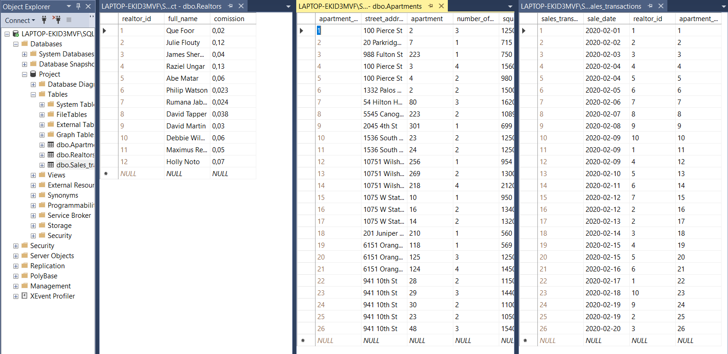

-------------------------------------------------------------------------

-- QUERIES

-------------------------------------------------------------------------

USE Project;

**--------------------------------------------------------------------------------------------**

**-- CREATE**

**--------------------------------------------------------------------------------------------**

--

--Create a new table with information about 3 bedroom's apartments.

--

SELECT apartment_id AS Three_bd_apartments_id,

street_adres,

apartment,

number_of_bd,

square_footage,

home_value

INTO Three_bd_apartments

FROM Apartments

WHERE number_of_bd=3;

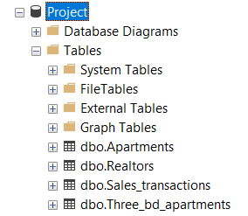

--

-- Create a backup for the table 'Apartment'

--

SELECT * INTO Apartments_backup

FROM Apartments;

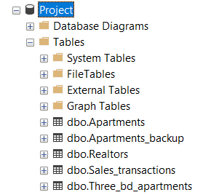

--------------------------------------------------------------------------------------------

-- READ

--------------------------------------------------------------------------------------------

--

-- Choose from the table `Apartments` only apartments that are located on South avenue and have 2 bd

--

SELECT *

FROM Apartments

WHERE street_adres='1536 South Ave' AND number_of_bd=2;

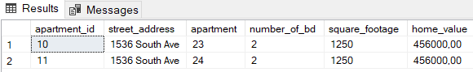

--

-- Choose from table `Realtors` whose name started with 'J' and who has the commission more than 0.10

--

SELECT *

FROM Realtors

WHERE full_name LIKE 'J%' AND comission>0.10;

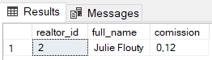

--

-- Calculate how many days are included in the report

--

SELECT COUNT(sale_date) AS sale_dates

FROM (SELECT DISTINCT sale_date FROM Sales_transactions) AS dist;

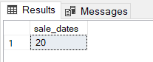

--

-- SHOW all realtors except David Martin

--

SELECT *

FROM Realtors

WHERE NOT full_name='David Martin'

ORDER BY full_name;

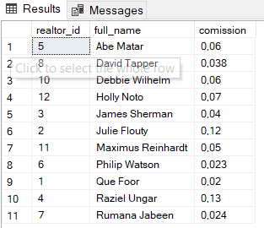

--

-- Select some apartments which have 2 bedrooms

--

SELECT TOP 3 *

FROM Apartments

WHERE number_of_bd=2;

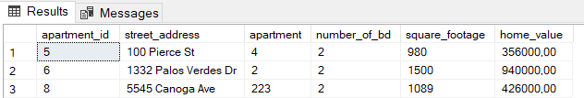

SELECT TOP 50 PERCENT *

FROM Apartments

WHERE number_of_bd=2;

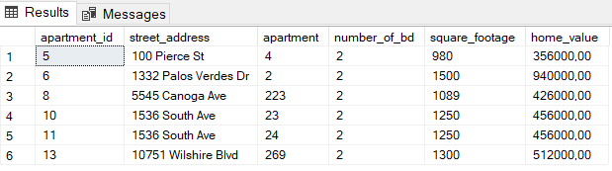

--

-- Select the most expensive and the cheapest apartments on 10th Street

--

SELECT MAX(Home_value) as the_most_expensive_ap, MIN(Home_value) as the_cheapest_ap

FROM Apartments

WHERE street_adres LIKE '%10th ST';

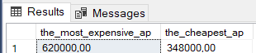

--

-- Select apartments with specific addresses

--

SELECT *

FROM Apartments

WHERE street_adres IN ('100 Pierce St', '6151 Orange St', '988 Fulton St');

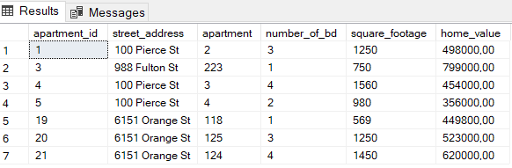

--

-- Select apartments , which were sold in between 2020-02-01 and 2020-02-10

--

SELECT a.*, s.sale_date

FROM Sales_transactions AS s

LEFT JOIN Apartments as a

ON s.apartment_id=a.apartment_id

WHERE sale_date BETWEEN '2020-02-01' AND '2020-02-10'

ORDER BY s.sale_date;

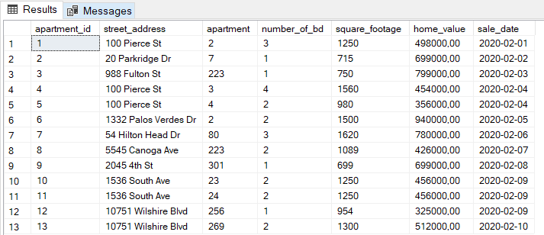

--

-- Choose 1 bedroom apartments that value in range from 500000 to 700000

--

SELECT *

FROM Apartments

WHERE number_of_bd=1 AND home_value>500000 and home_value<700000;

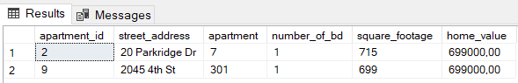

--

-- Calculate realtor's profit for each sales transaction.

--

SELECT r.full_name, s.sale_date, a.home_value, r.comission, a.home_value*r.comission as profit

FROM Apartments AS a

JOIN Sales_transactions AS s

ON a.apartment_id=s.apartment_id

JOIN Realtors AS r

ON s.realtor_id=r.realtor_id

ORDER BY r.full_name;

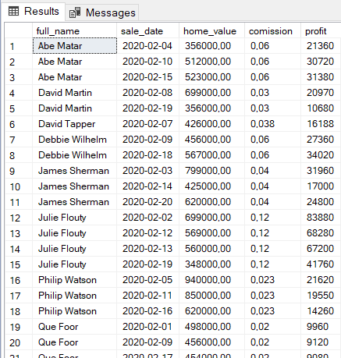

--

-- Combine apartments by number of bedrooms and calculate average square footage for each group

--

SELECT number_of_bd, AVG(square_footage) as average_footage

FROM Apartments

GROUP BY number_of_bd

ORDER BY number_of_bd;

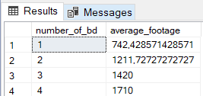

--

-- Combine apartments by square footage and calculate minimum and maximum number of bedrooms for each group.

--

SELECT square_footage, MIN(number_of_bd) as min_number_of_bd, MAX(number_of_bd) as max_number_of_bd

FROM Apartments

GROUP BY square_footage

ORDER BY square_footage;

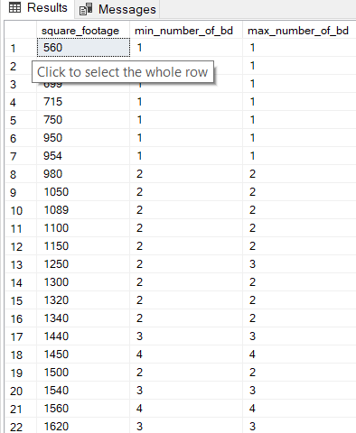

--

--Find realtors who have two and more transactions.

--

SELECT r.full_name, COUNT(s.sales_transaction_id) AS number_of_transactions

FROM Sales_transactions AS s

INNER JOIN Realtors AS r

ON s.realtor_id=r.realtor_id

GROUP BY r.full_name

HAVING COUNT(s.sales_transaction_id)=2 OR COUNT(s.sales_transaction_id)>2

ORDER BY number_of_transactions;

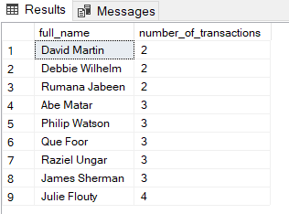

--

--Find realtors who sold at least one 3-bd apartment.

--

SELECT r.full_name,COUNT(s.sales_transaction_id) AS num_of_sold_ap

FROM Realtors AS r

INNER JOIN Sales_transactions AS s

ON r.realtor_id=s.sales_transaction_id

WHERE r.realtor_id = ANY (SELECT s.realtor_id

FROM Sales_transactions AS s

LEFT JOIN Apartments AS a

ON s.apartment_id=a.apartment_id

WHERE a.number_of_bd =3)

GROUP BY r.full_name;

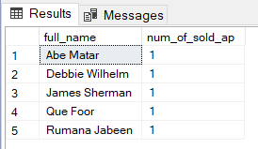

--------------------------------------------------------------------------------------------

-- UPDATE

--------------------------------------------------------------------------------------------

--

--Update the row.

--

UPDATE Apartments SET home_value=348500

WHERE home_value=34800;

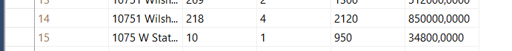

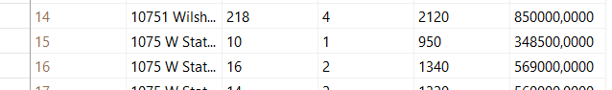

--

--Add column 'Phone column' to the table 'Realtors'.

--

ALTER TABLE Realtors

ADD Phone_number varchar(255);

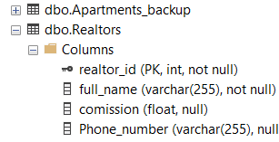

--

--Change the data type of the column 'Phone number' the table 'Realtors'.

--

ALTER TABLE Realtors

ALTER COLUMN Phone_number varchar(50);

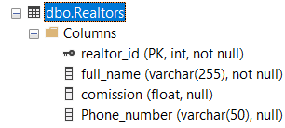

--------------------------------------------------------------------------------------------

-- DELETE

--------------------------------------------------------------------------------------------

--

-- Delete rows in the table 'Apartment' which is located on W State street.

--

DELETE

FROM Apartments_backup

WHERE street_adres LIKE '%State%';

--

--Delete the column 'Phone number' in the table 'Realtors'.

--

ALTER TABLE Realtors

DROP COLUMN Phone_number;

--

--Delete the data inside the table 'Three_bd_apartments'.

--

TRUNCATE TABLE Three_bd_apartments;

--

--Delete the table 'Three_bd_apartments'.

--

DROP TABLE Three_bd_apartments;

--

--Drop the existing SQL database 'Project'

--

DROP DATABASE Project;